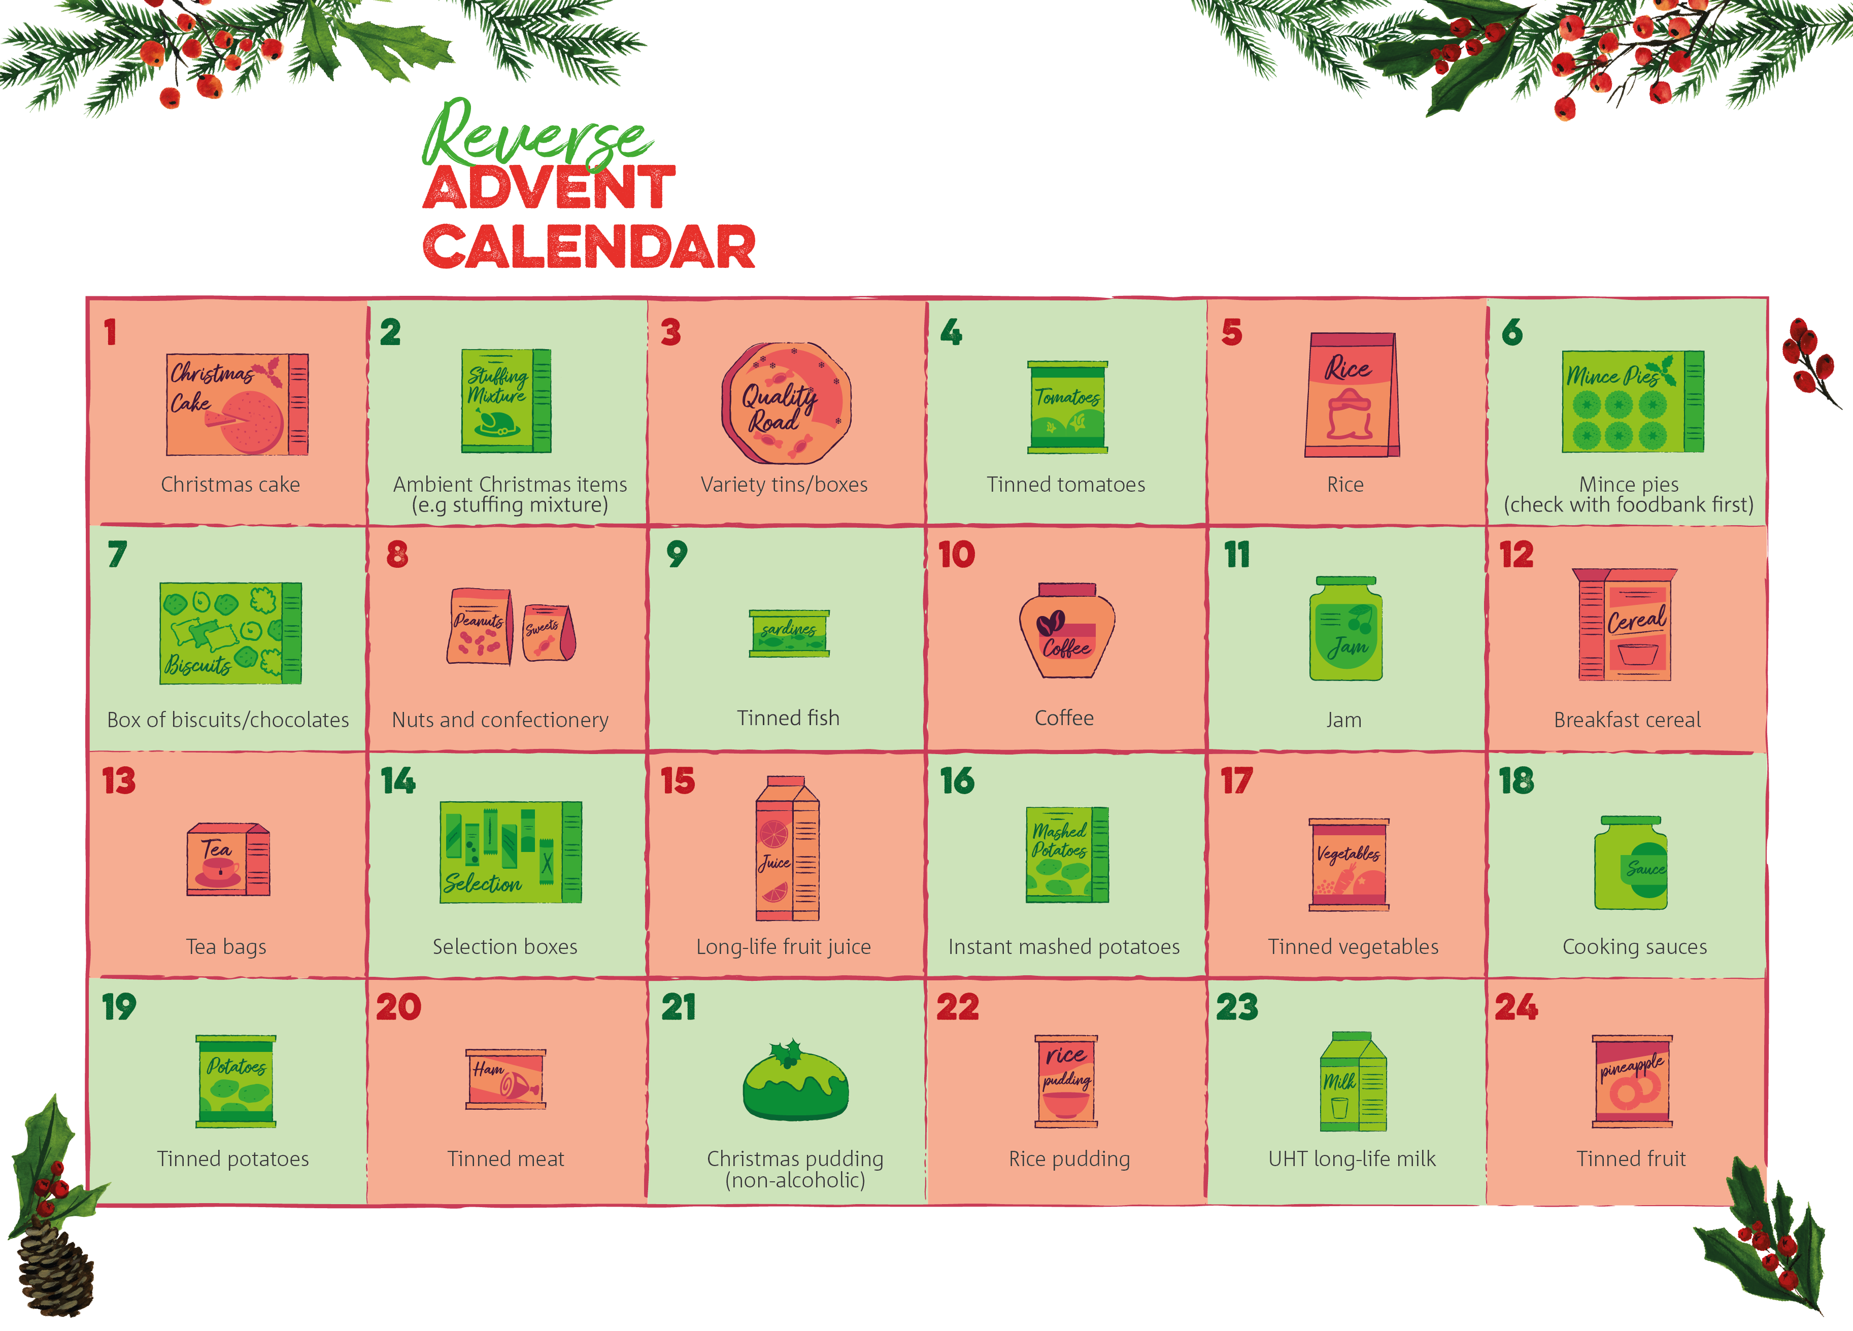

**An area to put any instructions or additional information:**

**e.g. Please check with us to find out our opening times around Christmas and to check if there is anything in particular we’re running short of.**

**Email address: foodbank@narthex.org.uk | Telephone Number: 0121 708 1398**

**sparkhill.foodbank.org.uk**

Registered Charity in England & Wales (1100358).