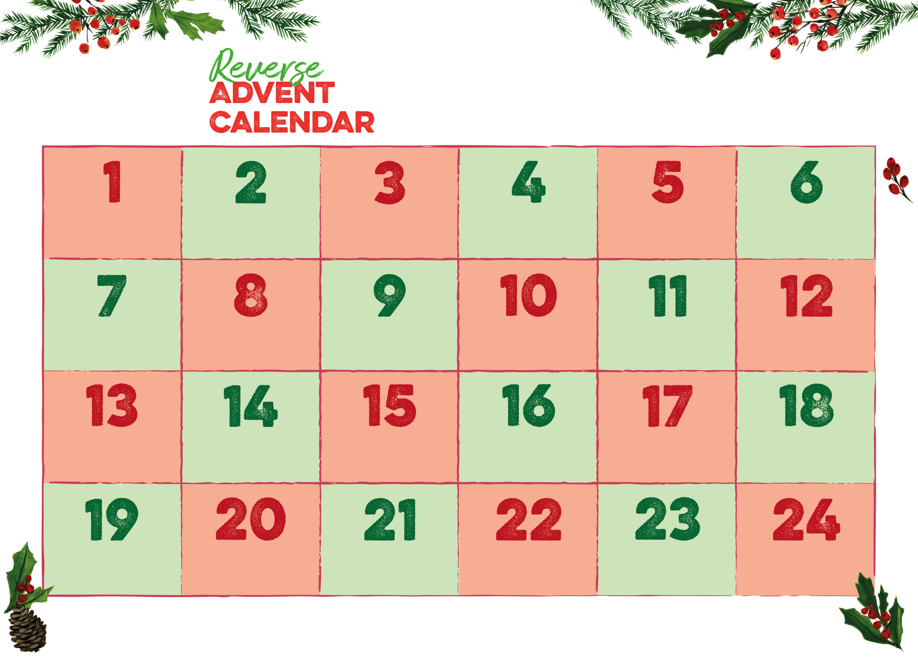

**Christmas Puddings**

Registered Charity in England & Wales (1100358).

**Tinned Potatoes**

**Tooth Paste**

**Tinned Soup**

**Soap**

**Biscuits**

**Shampoo**

**Tinned Carrots**

**Chocolate**

**Mince Pies**

**Razors**

**Milk**

**Ketchup/Sauce**

**Cooking Oil**

**Sponge Puddings**

**Tinned Fruit**

**Rice Pudding**

**Deodorant**

**Tinned peas**

**Chapati Flour**

**Sugar**

**Fruit Juice**

**Tinned Custard**

**Tinned Meat**

**These are the items in particular we’re running short of. We will be closed after Christmas Eve until 2nd Jan, so please make sure your donation reaches us by 17th so we can use them in our Christmas parcels**

**Email address: foodbank@narthex.org.uk | Telephone Number: 0121 708 1398**

**sparkhill.foodbank.org.uk**